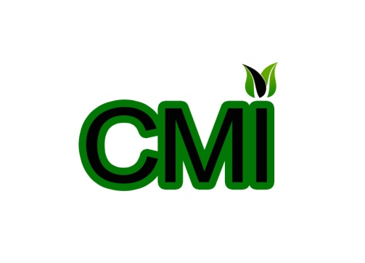

PLEASE WRITE IN BLOCK CAPITALS OR TYPE

Annual fee structure
£10 Individuals
£40 Community organisations
£50 National bodies, regional bodies
International

Name: ____________________________________________________________________________
Personal Address: ___________________________________________________________________
___________________________________________________________________
Postcode: _________________________________________________________________________
Email address: ______________________________________________________________________
Contact number for text updates: ______________________________________________________
Job title and brief description: _________________________________________________________
___________________________________________________________________
Organisation if applicable: ____________________________________________________________
___________________________________________________________________
Organisation address: ________________________________________________________________
Contact number: ____________________________________________________________________

Does your company take volunteers?
Yes No

Interests (this will be used to send you news based on your interests)
Women rights | Children | Poverty | Politics | Community Engagement | Local/ Grass-root issues
Youth | LGBT rights | Fundraising | Health | Sustainability
Men rights | Ethnic minorities | Disabilities | Community Social Responsibility (CSR) | Education

Name |  | Signature
Position |  | Date

Thank you for filling in this form. This information will be kept on CMI World database and will not be shared with other without your expressed consent. The data may be used for statistical purposes.

Please return completed forms to CMI World, at info@cmiworld.org.uk or CMI world, Impact, Lambeth, London, SW2 1RW or call/text +44 (0)7956080533.

